** NAAN MUDHALVAN**

**VIVEKANANDHA COLLAGE OF TECHNOLOGY FOR WOMEN**

**DEPARTMENT OF COMPUTER SCIENCE AND ENGINEERING**

**NAAN MUDHALVAN PROJECT REPORT**

**PROJECT TITLE : CREATING A SOCIAL MEDIA AD CAMPAIGN IN FACEBOOK**

**SUBMITTED BY,**

**CHANDRIKA .S 613020104012**

**GOWRI .R 613020104021**

**GUNAMATHI .V.S 613020104022**

**HARSHINI .R 613020104024**

**VIVEKANANDHA COLLEGE OF TECHNOLOGY**

**FOR WOMEN ELAYAMPALAYAM,**

**TIRUCHENGODE-637 205**

**NAAN MUDHALVAN : DIGITAL MARKETING**

PROJECT TITLE : CREATING A SOCIAL MEDIA AD CAMPAIGN IN FACEBOOK

**CREATING A LOGO FOR OUR BRAND**

STEP 1 : USING CANVA TO CREATE THE LOGO FOR THE BRAND

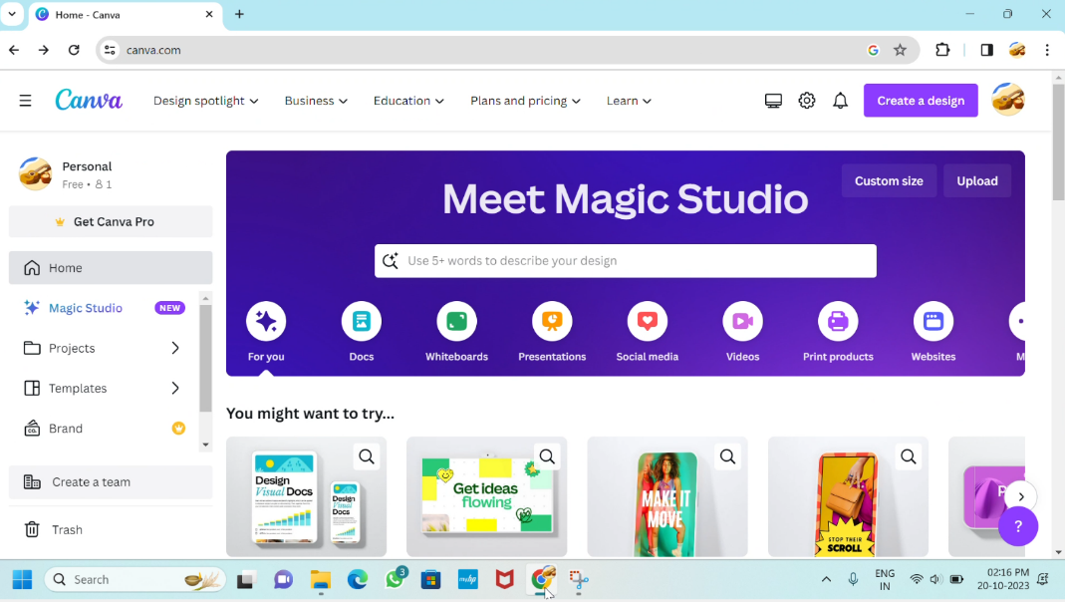

STEP 2 : CUSTOMIZE THE SELECTED TEMPLATE FROM THE CANVA

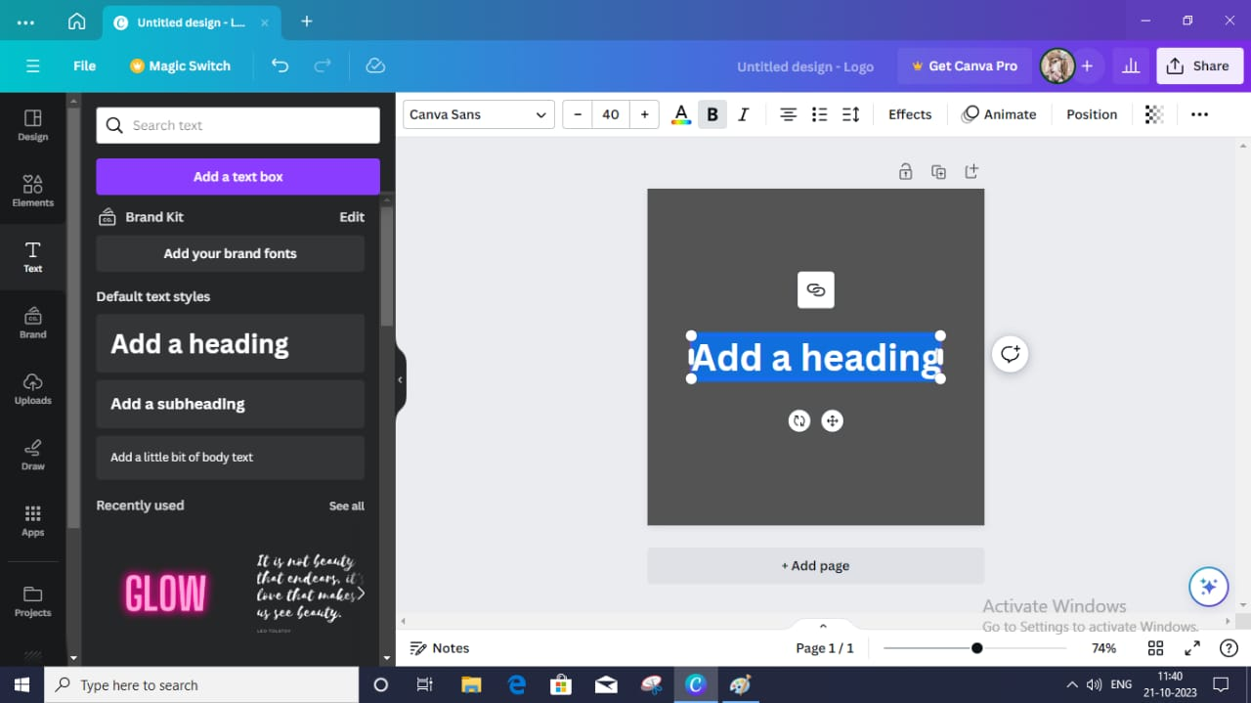

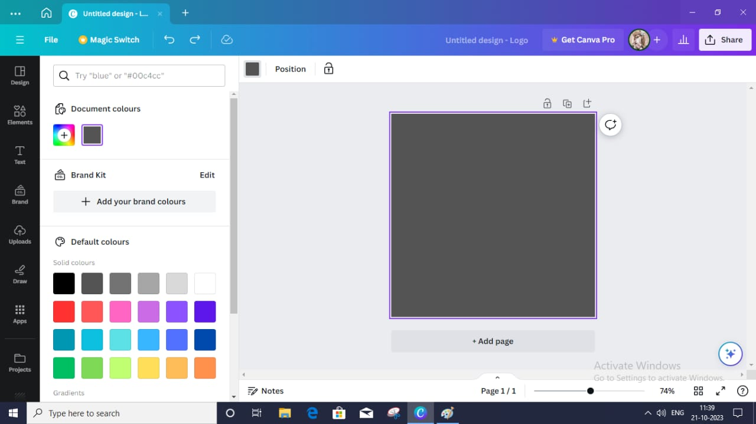

STEP 3 : NOW THE CUSTOMIZED LOGO IS READY

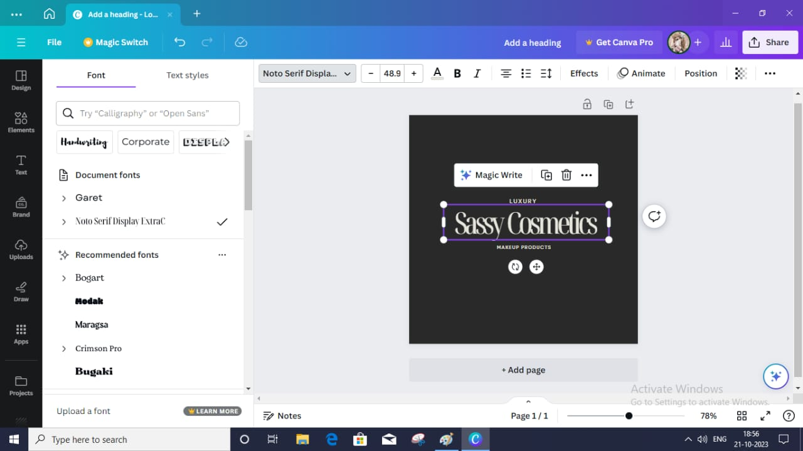



**CREATING A GMAIL ACCOUNT FOR THE BRAND**

STEP 1 : CREATE A NEW GMAIL ACCOUNT FOR THE BRAND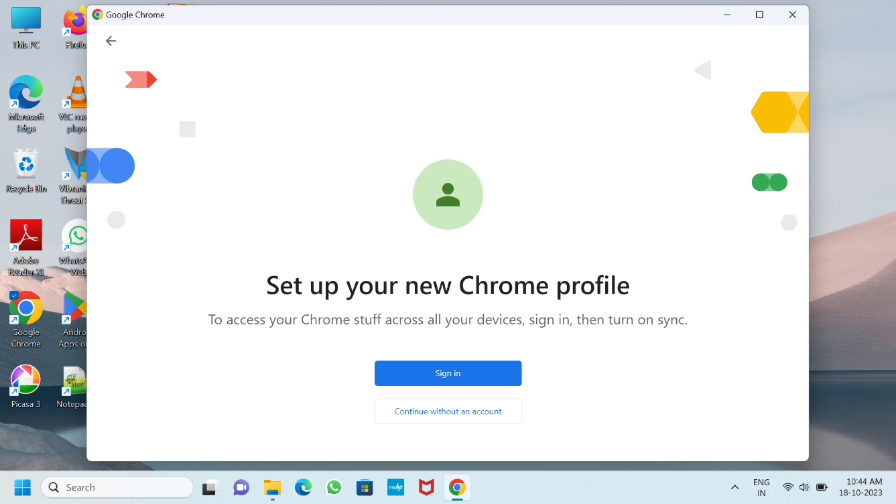

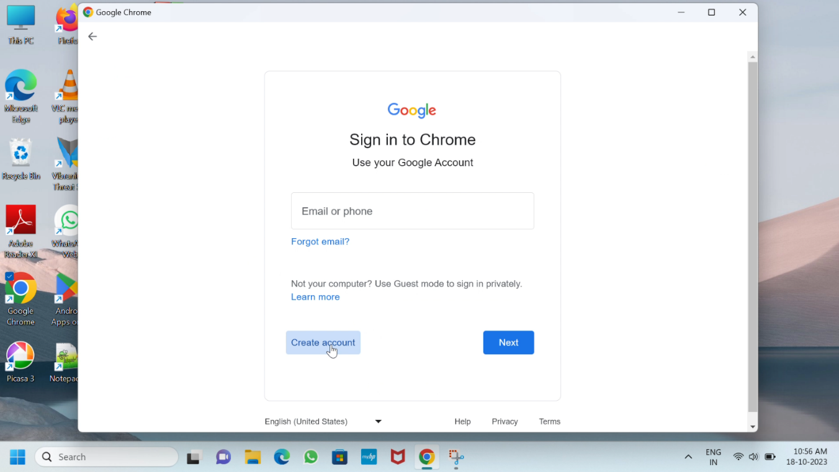

STEP 2 : CUSTOMIZE OUR OWN GMAIL ADDRESS FOR OUR BRAND

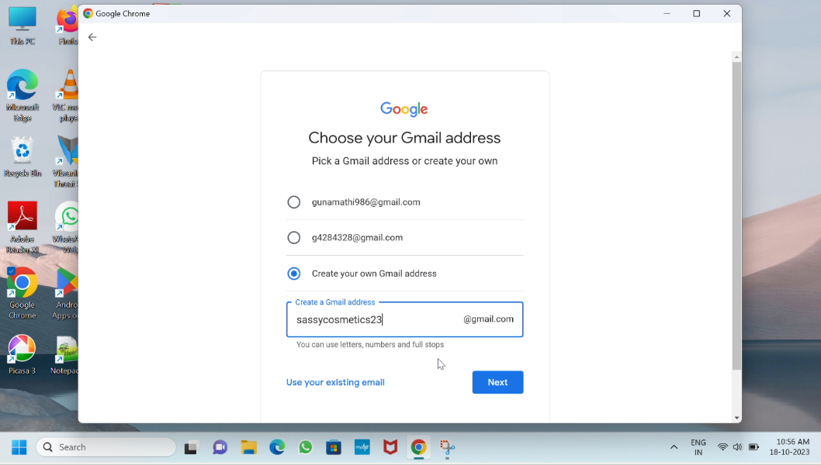

STEP 3 : SET PASSWORD FOR THE GMAIL ADDRESS

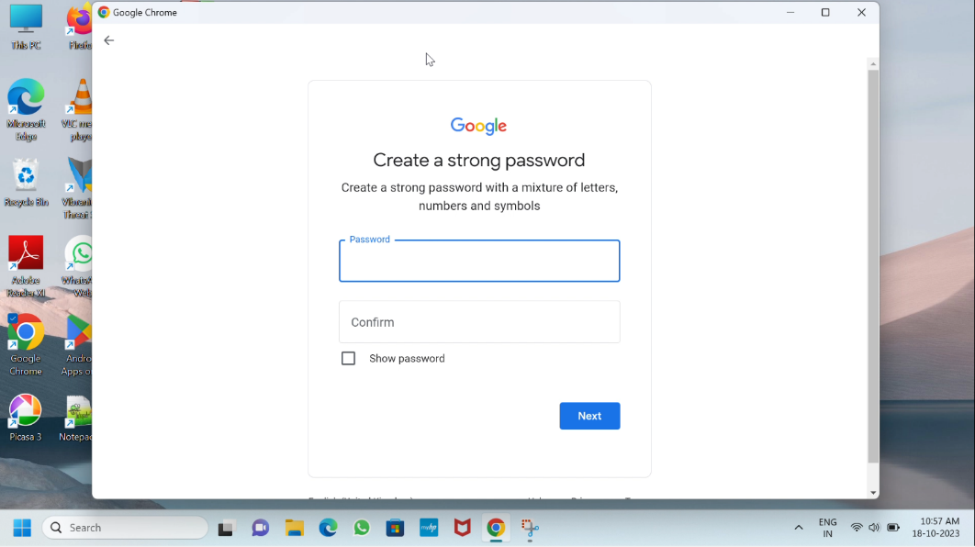

STEP 4 : AFTER VERIFICATION WE CAN USE THE GMAIL ADDRESS

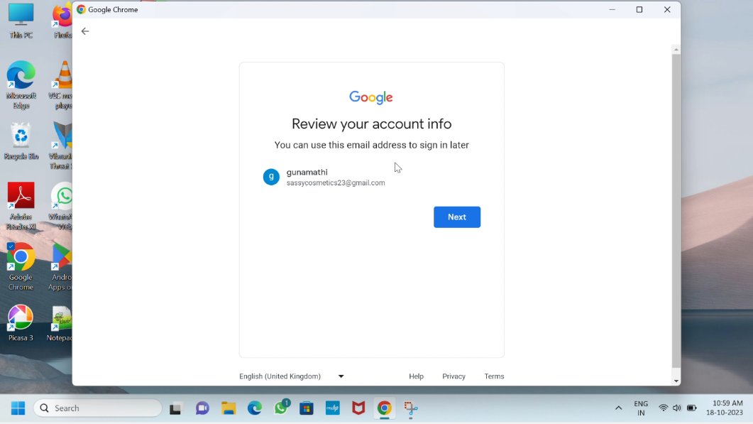

**CREATING A ADVERTISEMENT VIDEO FOR POSTING IN FACEBOOK**

STEP 1: USING CANVA TO CREATE THE ADVERTISEMENT VIDEO

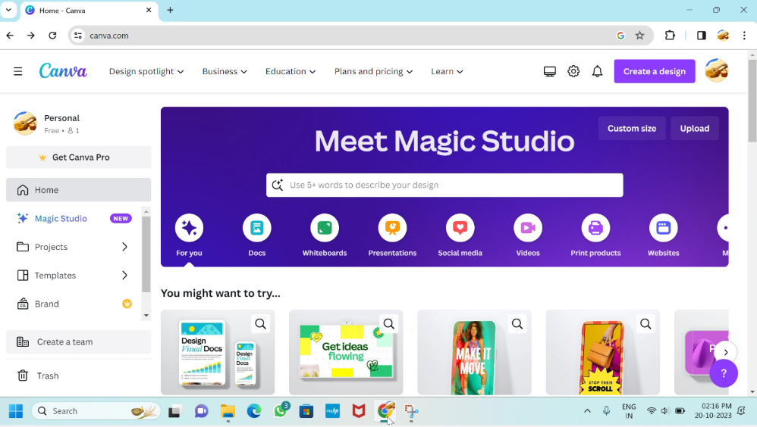

STEP 2: SEARCH THE TEMPLATE FOR YOUR USAGE

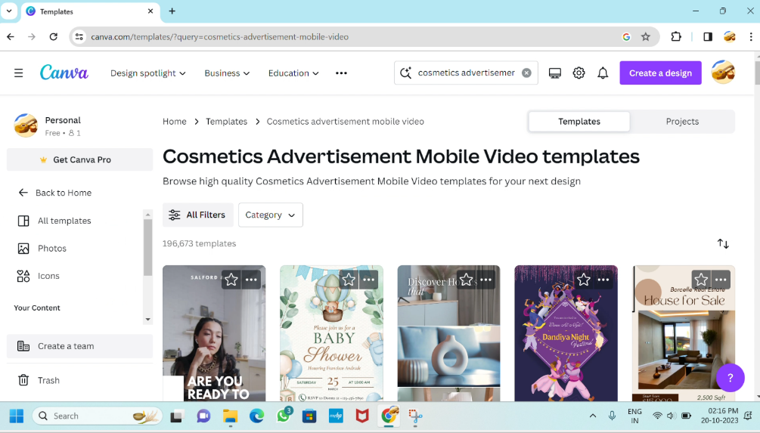

STEP 3: CHOOSE THE TEMPLATE FROM THE CANAVA

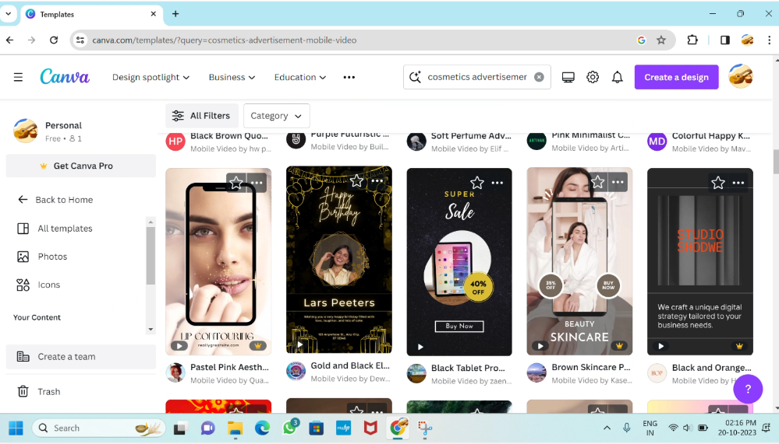

STEP 4: CUSTOMIZE THE CHOOSEN TEMPLATE FOR ADVERTISEMENT

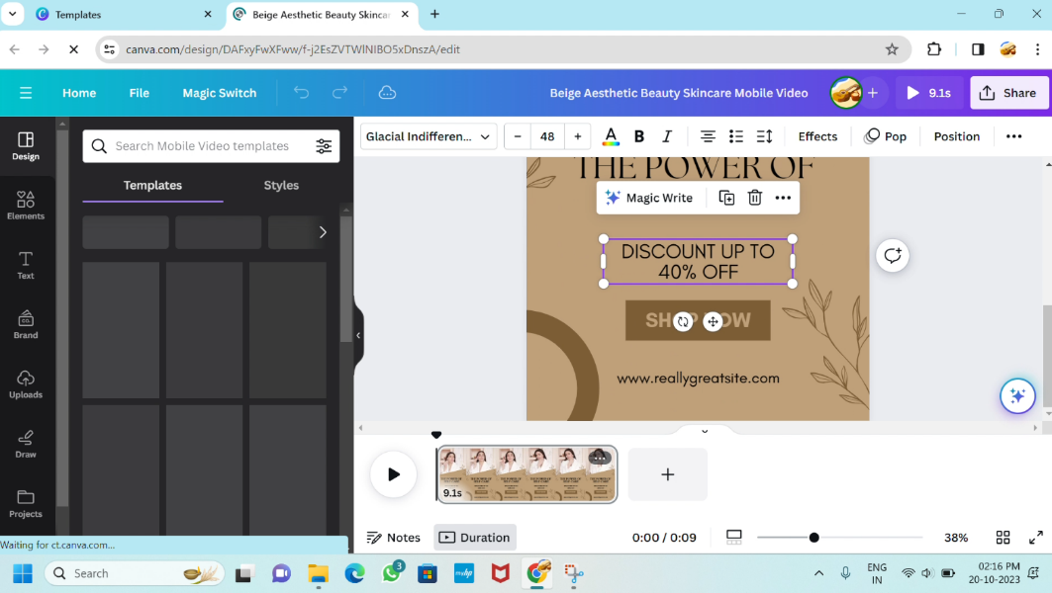

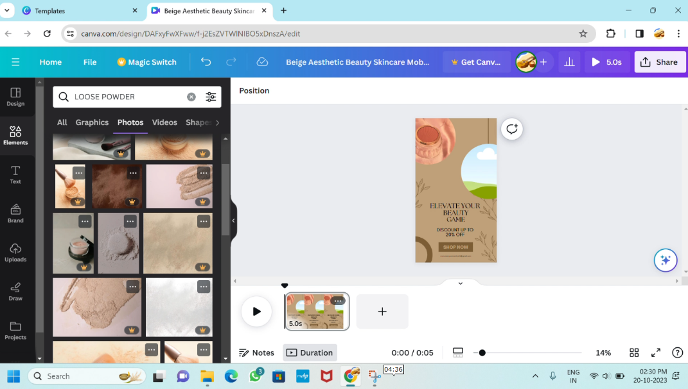

STEP 5: INSERT THE BRAND LOGO IN THE VIDEO

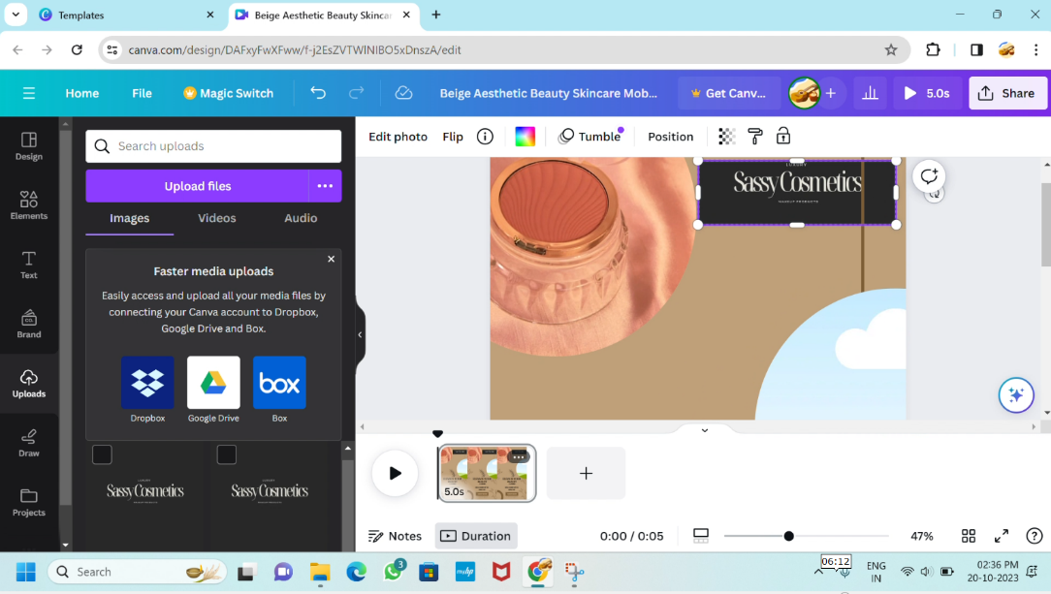

STEP 6: DOWNLOAD THE CUSTOMIZED VIDEO TEMPALTE FROM THE CANVA

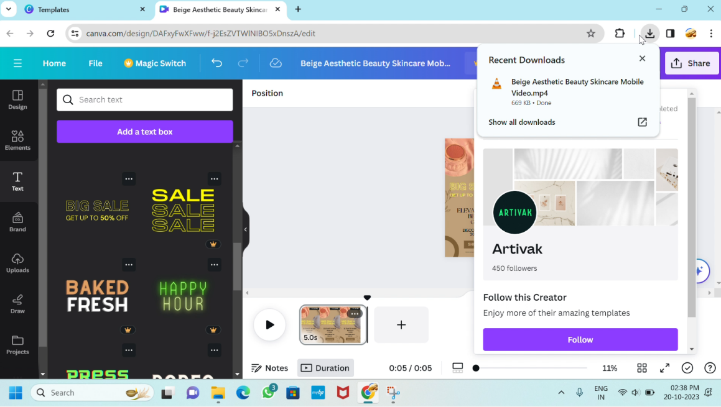



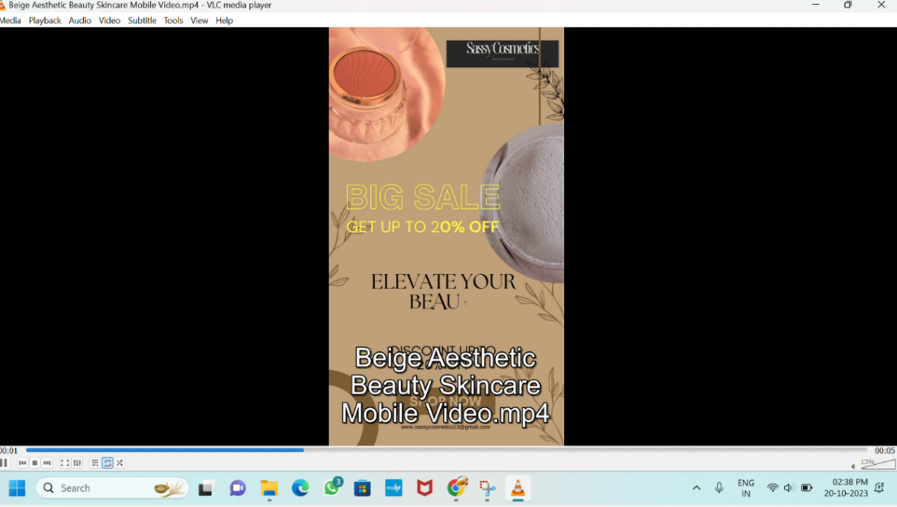

**CREATING A ADVERTISEMENT POSTER FOR THE BRAND**

STEP 1 : CREATING A ADVERTISEMENT POSTER USING THE CANVA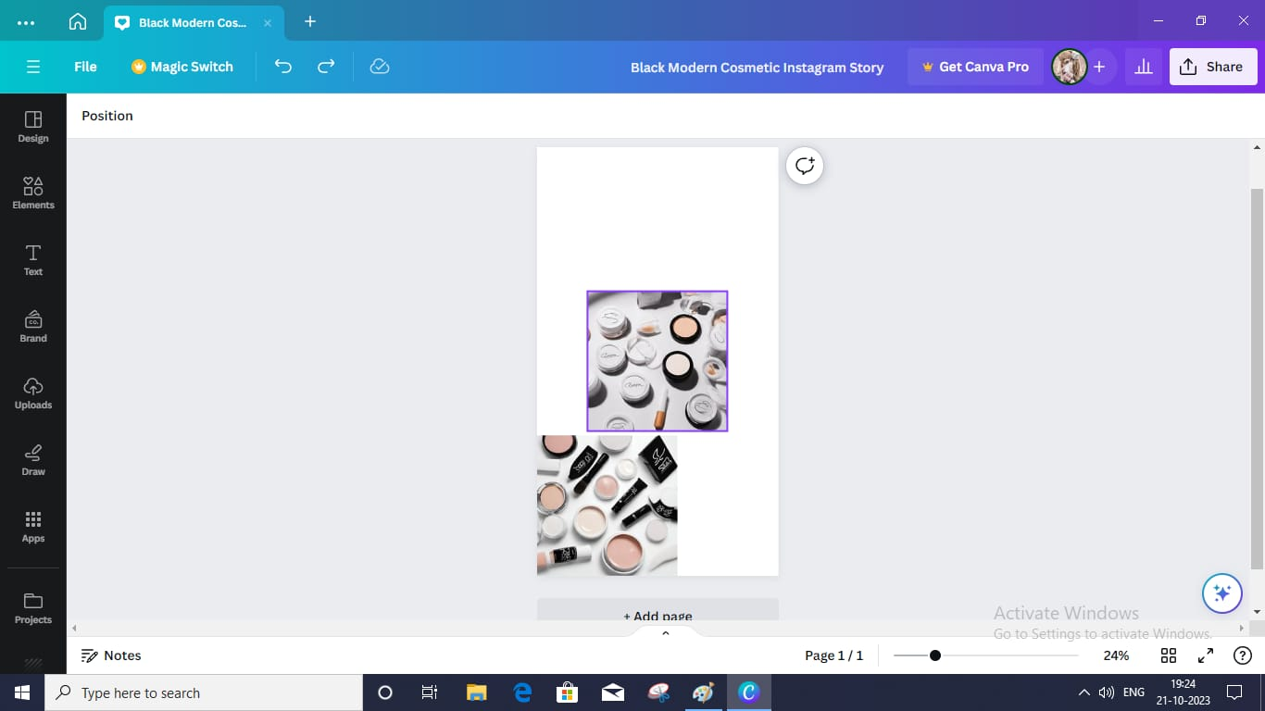

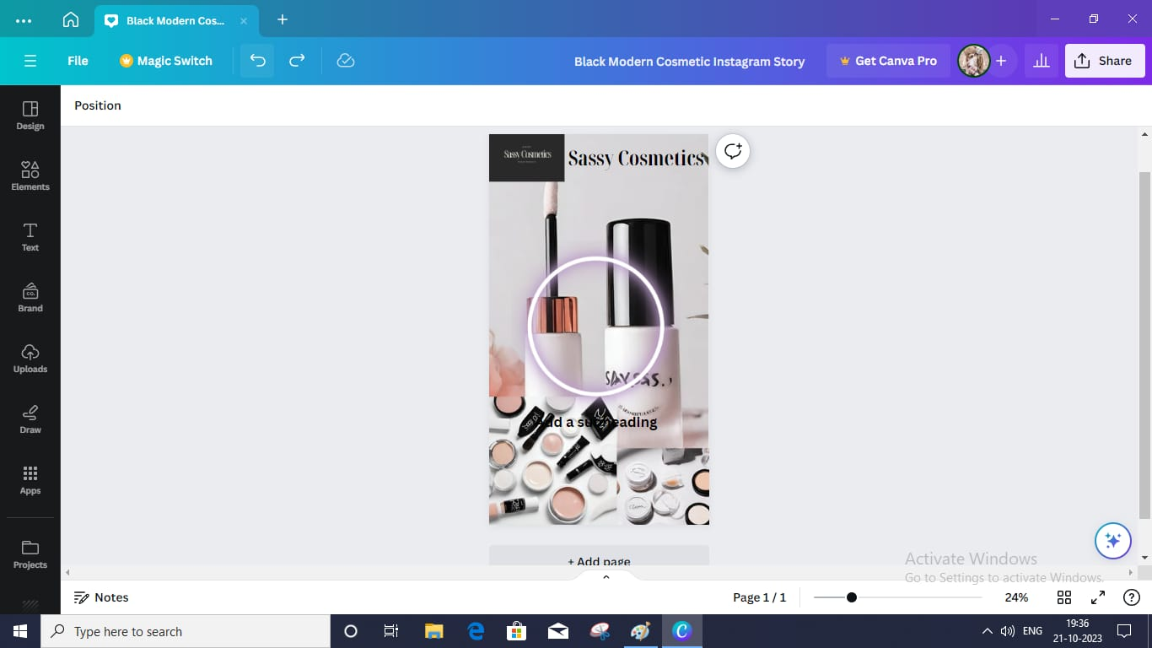

STEP 2 : CUSTOMIZE THE TEMPLATE FOR OUR PURPOSE

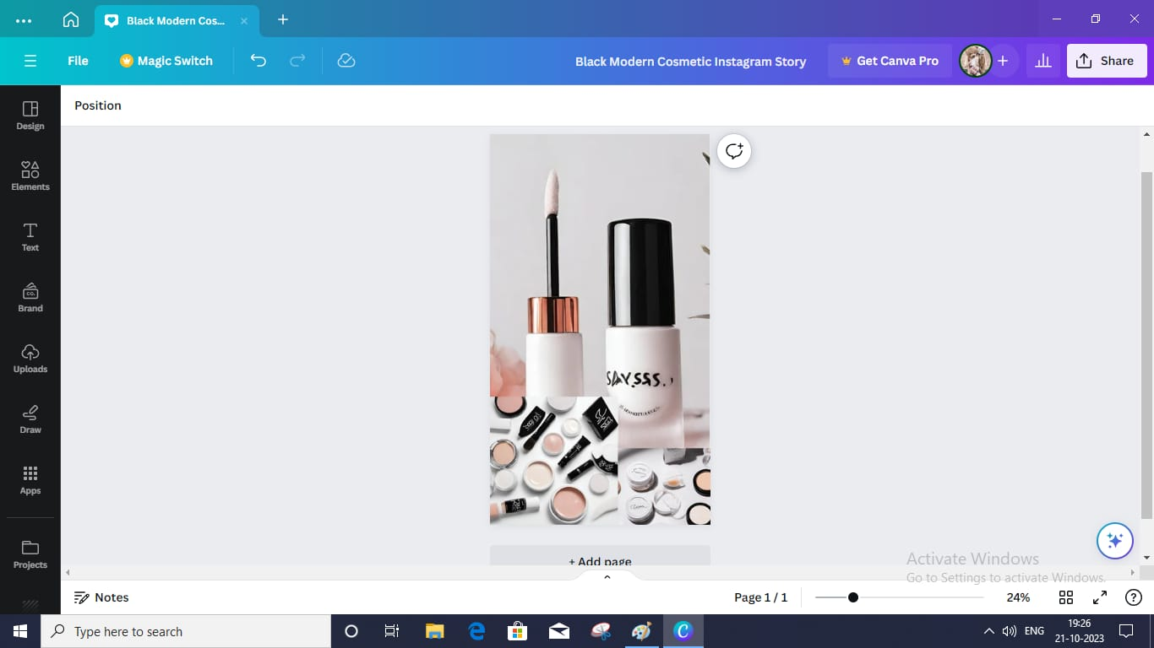



**SCREEN SHOTS OF THE UPLOADED ADVERTISEMENT POST OF THE TEAM MEMBERS**

S.CHANDRIKA – 613020104012

|  |  |
| --- | --- |
|  |  |

R.GOWRI – 613020104021

|  |  |
| --- | --- |
|  |  |

V.S.GUNAMATHI – 613020104022

|  |  |
| --- | --- |
|  |  |

R.HARSHINI – 613020104024

|  |  |
| --- | --- |
|  |  |

**ADVERTISEMENT POSTER DESIGN**



**VIDEO ADVERTISEMENT POSTER**

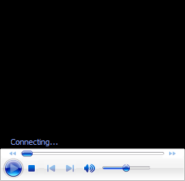

**ATTACHMENT OF THE VIDEO:**

